Consider the signal

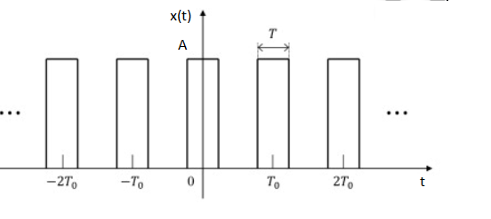

a) Find the exponential Fourier series , i.e., determine $X[k]$ such that:

$$x\left(t\right)=\sum_{k=-∞}^{+∞}{X\left[k\right]e^{jkω_{0}t}}$$

b) Find the trigonometric Fourier series.



The periodic signal $x(t)$ is given in **Figure 1**:

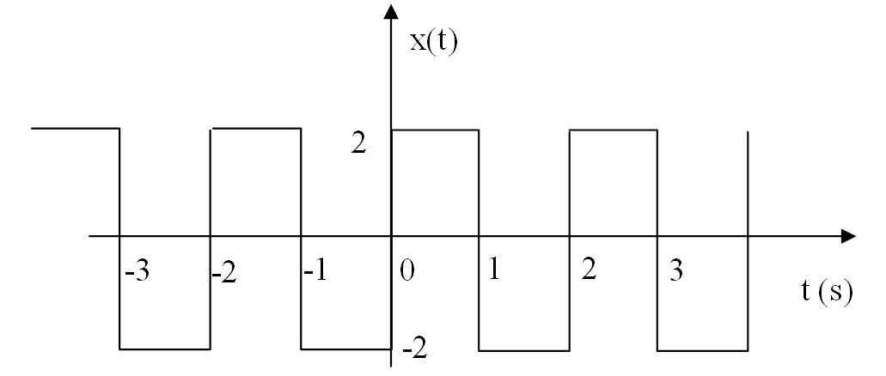

Figure 1

a) Determine the power of the signal $x(t)$.

b) Find the exponential Fourier coefficients of the signal $x(t)$.



Consider the signal

$$x\left(t\right)=\left|6\cos{(100πt)}\right|$$

a) Sketch the signal $x(t)$.

b) Find the exponential Fourier series , i.e., determine $X[k]$ such that:



$$x\left(t\right)=\sum_{k=-∞}^{+∞}{X\left[k\right]e^{jkω_{0}t}}$$

a) Consider a high-pass filter with the frequency response $H\left(ω\right)=\frac{jω}{1+jω}$. Determine the steady state output $y\left(t\right)$ of the system for the input $x\left(t\right)=2\cos\left(2t\right)+cos⁡(100t)$.

b) Let:

$$x\left(t\right)=\left\{\begin{aligned}1, -1≤t≤1 \\ 0, elsewhere\end{aligned}\right.$$

Using the definition of the Fourier transform find the Fourier transform $X(ω)$ of the signal $x(t)$.



a) Consider filter with the frequency response $H\left(ω\right)=\frac{1+j0.01ω}{1+j0.1ω}$. Determine (steady-state) output $y(t)$ of the system for the input $x\left(t\right)=5+2\cos\left(5t\right)-cos⁡(200t)$.

b) Let:

$$x\left(t\right)=\left\{\begin{aligned}1, -2≤t≤2 \\ 0, elsewhere\end{aligned}\right.$$

Using the definition of the Fourier transform, find the Fourier transform $X(ω)$ of the signal $x(t)$.

Consider the LTI system having the unit impulse response:

$$h\left(t\right)=e^{-5t}u(t)$$

a) Find the frequency response $H\left(ω\right)$.

b) Find the response $y(t)$ for the input signal

$$x\left(t\right)=5+2\cos\left(2t-30°\right)-4sin⁡(10t+20°)$$

a) Consider the following signal:

$$x\left(t\right)=6\cos\left(20t\right)+4cos⁡(100t)$$

Find and sketch the spectrum $X\left(ω\right)$, and determine the power of signal $x(t)$.

b) The modulated signal $y\left(t\right)$ is defined by

$$y\left(t\right)=\left[12+x\left(t\right)\right]cos⁡(500t)$$

Find and sketch the spectrum $Y\left(ω\right)$, and calculate the power of $y\left(t\right)$.

Consider a causal LTI system with frequency response

$$H\left(jω\right)=\frac{1}{jω+3}$$

For a particular input $x\left(t\right)$ this system produces the output

$$y\left(t\right)=e^{-3t}u\left(t\right)-e^{-4t}u\left(t\right)$$

Determine $x(t)$.



Consider a casual LTI system whose response (output) is $y\left(t\right)=e^{-5t}u(t)$ for the input $x\left(t\right)=e^{-2t}u(t)$.

a) Find the transfer function  and the unit impulse response $h(t)$.

b) Find the zero-state response $y\left(t\right)$ of the system if the input signal is $x\left(t\right)=2e^{-4t}$

$u\left(t\right)$.



Consider the causal filter with the transfer function

$$H\left(s\right)=\frac{Y\left(s\right)}{X\left(s\right)}=\frac{100s+10000}{(s+10)(s+1000)}$$

a) Determine the expression of the magnitude response in dB and use the Bode plot to sketch the magnitude response.

b) Find the zero-state response $y(t)$ of the system if the input signal is $x\left(t\right)=e^{-50t}u\left(t\right)$.



Consider the following circuit with $R=10 kΩ, C=2 μF$.

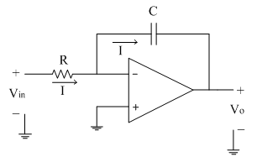

a) Find the transfer function $H\left(s\right)=\frac{V_{o}\left(s\right)}{V_{i}\left(s\right)}$.

b) Find the frequency response $H(ω)$.

c) Sketch the magnitude response $\left|H\left(ω\right)\right|$ and phase response $∠H\left(ω\right)$.

d) Find $y(t)$ for $x\left(t\right)=5\cos\left(10t\right)+6\cos\left(20t\right)$.

In **Figure 2**, the op-amp is ideal and $R_{1}=10$ kΩ, $R_{2}=100$ kΩ, $C=0.1$ µF.

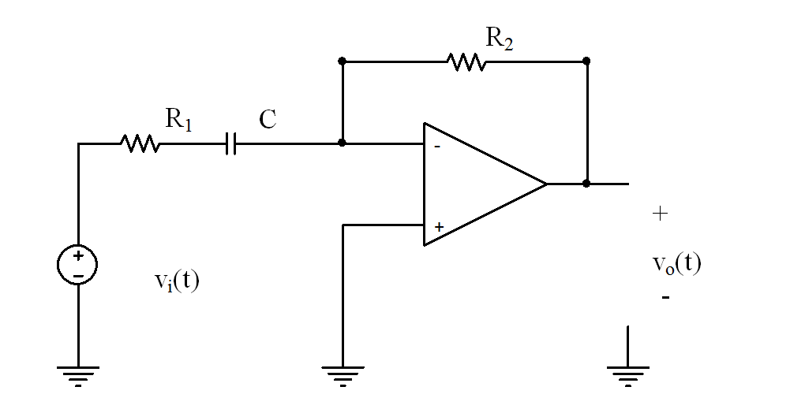

Figure

a) Find the transfer function $H\left(s\right)=\frac{V_{o}\left(s\right)}{V_{i}\left(s\right)}$ where $V_{i}\left(s\right),$ $V_{o}\left(s\right)$ are the Laplace transforms of $v_{i}\left(t\right), v_{o}(t)$, respectively.

b) Find the frequency response $H(ω)$ and calculate the magnitude response at the given frequencies in Table below. Sketch the magnitude $A(ω)$ in dB.

|  |  |  |  |  |  |
| --- | --- | --- | --- | --- | --- |
| $ω$ (rad/s) | 1 | 10 | 100 | 1000 | 10000 |
|  |  |  |  |  |  |
|  |  |  |  |  |  |